M. Rohith(192424054)
DSA0602-Data Handling And Visualization
Class Activity 1
Scenario 1: Student Academic Performance Dashboard
CODE:
import pandas as pd
import matplotlib.pyplot as plt
import seaborn as sns
sns.set(style="whitegrid")
df = pd.DataFrame({
"Student_ID": ["S1","S2","S3","S4","S5","S6","S7","S8"],
"Attendance": [92, 85, 78, 88, 95, 70, 82, 90],
"Internal_Marks": [88, 76, 69, 80, 91, 60, 72, 85],
"Department": ["CSE", "AI", "IT", "ECE", "CSE", "IT", "AI", "ECE"]
})
plt.figure(figsize=(8,5))
sns.scatterplot(data=df, x="Attendance", y="Internal_Marks", hue="Department", s=100)
plt.title("Student Academic Performance Dashboard")
plt.xlabel("Attendance (%)")
plt.ylabel("Internal Marks")
plt.legend(title="Department")
plt.show()
OUTPUT:
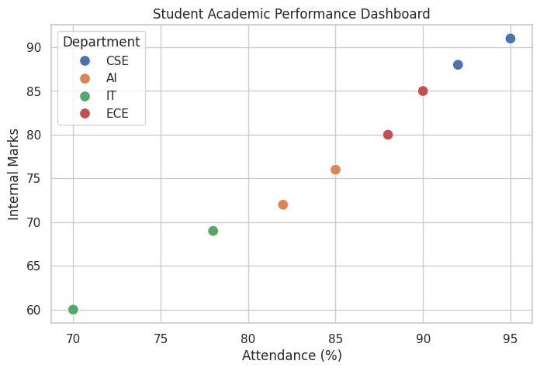
Scenario 2: Electric Vehicle Market Analysis
CODE:
import pandas as pd
import matplotlib.pyplot as plt
import seaborn as sns

sns.set(style="whitegrid")

df = pd.DataFrame({
"Vehicle_Model": ["EV1", "EV2", "EV3", "EV4", "EV5", "EV6"],
"Battery_Capacity": [30, 40, 50, 60, 75, 90],
"Price": [8, 10, 14, 18, 24, 30], # in lakhs
"Driving_Range": [200, 250, 320, 380, 450, 520],
"Manufacturer": ["Tata", "Mahindra", "Tata", "MG", "Hyundai", "BYD"]
})

plt.figure(figsize=(8,5))
sns.scatterplot(
data=df,
x="Battery_Capacity",
y="Price",
size="Driving_Range",
hue="Manufacturer",
sizes=(100, 800)
)

plt.title("Electric Vehicle Market Analysis")
plt.xlabel("Battery Capacity (kWh)")
plt.ylabel("Price (Lakhs)")
plt.show()
OUTPUT:
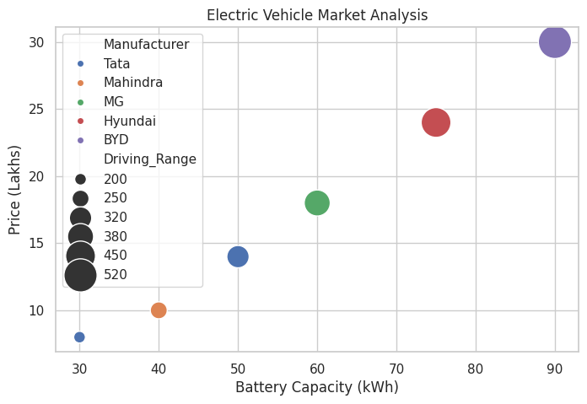
Scenario 3: Hospital Patient Admission Analysis
CODE:
import pandas as pd
import matplotlib.pyplot as plt

df = pd.DataFrame({
"Department": ["Cardiology", "Orthopedics", "Neurology", "Pediatrics", "General"],
"Number_of_Patients": [120, 90, 70, 110, 150],
"Average_Treatment_Cost": [5000, 4000, 6500, 3000, 2500]
})

plt.figure(figsize=(8,5))
bars = plt.bar(df["Department"], df["Number_of_Patients"],
color=["red","blue","green","orange","purple"])

plt.title("Hospital Patient Admission Analysis")
plt.xlabel("Department")
plt.ylabel("Number of Patients")

for bar, cost in zip(bars, df["Average_Treatment_Cost"]):
plt.text(bar.get_x() + bar.get_width()/2, bar.get_height()+2,
f"₹{cost}", ha='center')

plt.show()
OUTPUT:
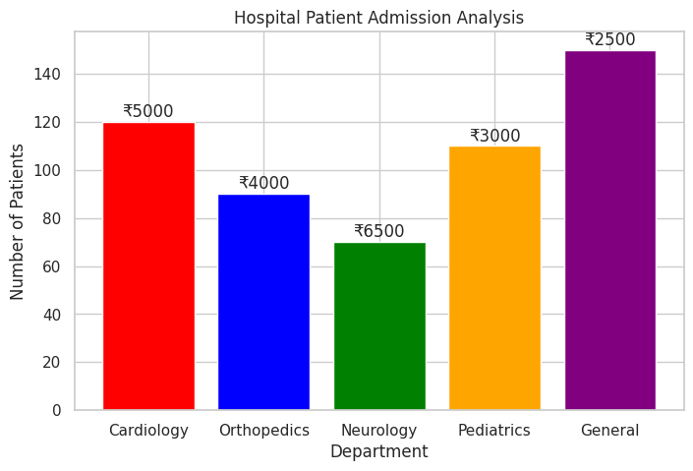
Scenario 4: Weather Monitoring System
CODE:
import pandas as pd
import matplotlib.pyplot as plt

df = pd.DataFrame({
"Date": ["2026-07-01","2026-07-02","2026-07-03","2026-07-04","2026-07-05"]*3,
"Temperature": [32,33,31,34,35, 28,29,30,31,30, 35,36,34,37,38],
"City": ["Chennai"]*5 + ["Bangalore"]*5 + ["Delhi"]*5
})

df["Date"] = pd.to_datetime(df["Date"])

plt.figure(figsize=(10,5))
cities = df["City"].unique()
line_styles = ["-", "--", ":"]

for city, style in zip(cities, line_styles):
city_data = df[df["City"] == city]
plt.plot(city_data["Date"], city_data["Temperature"],
label=city, linestyle=style, marker='o')

plt.title("Weather Monitoring System")
plt.xlabel("Date")
plt.ylabel("Temperature (°C)")
plt.legend()
plt.show()
OUTPUT:
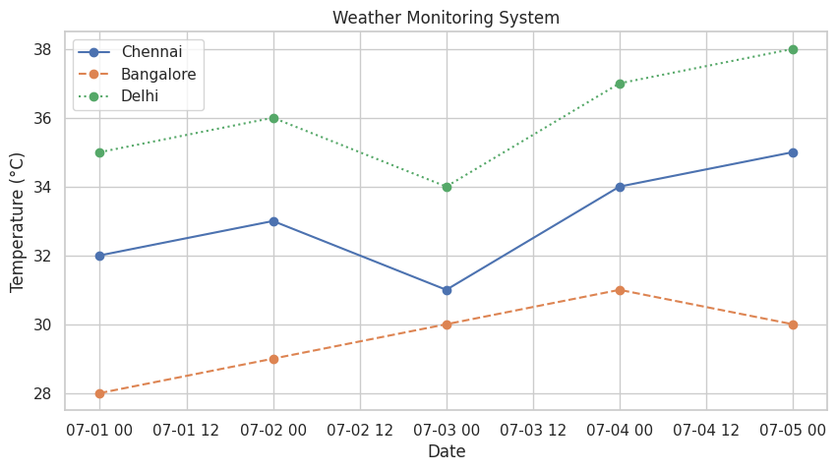
Scenario 5: Supermarket Sales Analysis
CODE:
import pandas as pd
import matplotlib.pyplot as plt
import seaborn as sns
sns.set(style="whitegrid")
df = pd.DataFrame({
"Month": ["Jan","Jan","Jan","Jan","Feb","Feb","Feb","Feb","Mar","Mar","Mar","Mar"],
"Product_Category": ["Snacks","Beverages","Snacks","Beverages"]*3,
"Sales_Amount": [20000,15000,18000,16000,22000,17000,21000,18000,25000,19000,23000,20000],
"Branch": ["A","A","B","B"]*3
})
plt.figure(figsize=(10,5))
sns.barplot(data=df, x="Month", y="Sales_Amount", hue="Branch")

plt.title("Supermarket Sales Analysis")
plt.xlabel("Month")
plt.ylabel("Sales Amount")
plt.show()
OUTPUT:
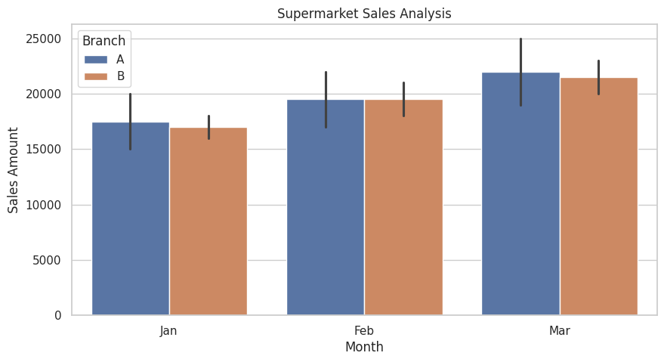
Scenario 6: Employee Salary Distribution
CODE:
import pandas as pd
import matplotlib.pyplot as plt
df = pd.DataFrame({
"Employee_ID": ["E1","E2","E3","E4","E5","E6","E7","E8","E9","E10"],
"Salary": [25000, 30000, 28000, 35000, 40000, 45000, 50000, 52000, 60000, 70000],
"Experience": [1,2,2,3,4,5,6,7,8,10],
"Department": ["HR","IT","IT","Sales","Finance","IT","Sales","HR","Finance","Management"]
})
plt.figure(figsize=(8,5))
plt.hist(df["Salary"], bins=5, edgecolor="black")
plt.title("Employee Salary Distribution")
plt.xlabel("Salary")
plt.ylabel("Frequency")
plt.show()
OUTPUT:
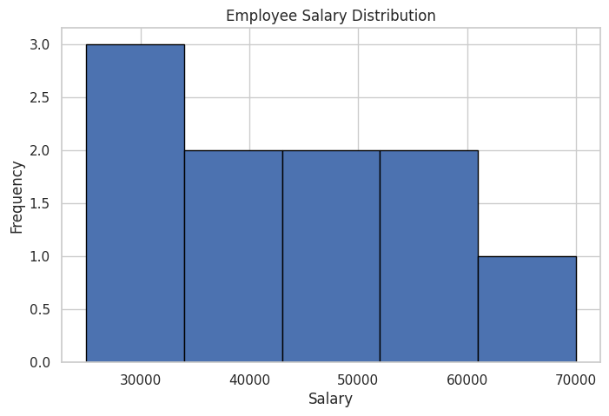
Scenario 7: Smartphone Market Comparison
CODE:
import pandas as pd
import matplotlib.pyplot as plt
import seaborn as sns

sns.set(style="whitegrid")

df = pd.DataFrame({
"Brand": ["Samsung", "Apple", "OnePlus", "Xiaomi", "Samsung", "Apple"],
"RAM": [6, 8, 12, 8, 16, 12],
"Processor_Speed": [2.4, 3.0, 3.2, 2.8, 3.1, 3.3],
"Price": [25000, 70000, 45000, 22000, 60000, 85000],
"Storage": [128, 256, 256, 128, 512, 512]
})

plt.figure(figsize=(9,6))
sns.scatterplot(
data=df,
x="RAM",
y="Price",
hue="Processor_Speed",
size="Storage",
style="Brand",
sizes=(100, 500)
)
plt.title("Smartphone Market Comparison")
plt.xlabel("RAM (GB)")
plt.ylabel("Price")
plt.show()
OUTPUT:
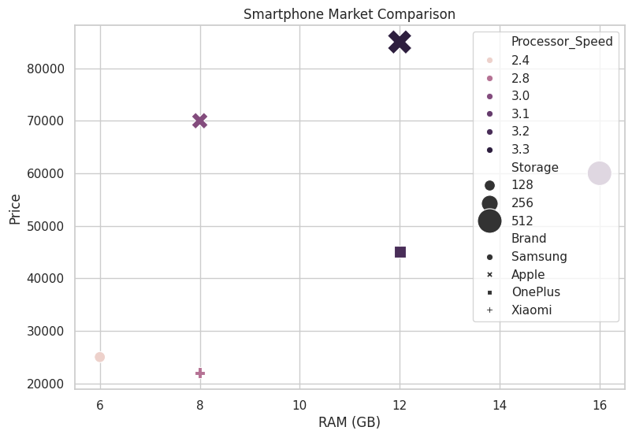
Scenario 8: Online Movie Rating Analysis
CODE:
import pandas as pd
import matplotlib.pyplot as plt
import seaborn as sns

sns.set(style="whitegrid")

df = pd.DataFrame({
"Genre": ["Action", "Comedy", "Drama", "Horror", "Sci-Fi"]*3,
"Average_Rating": [7.8, 6.9, 8.2, 6.5, 8.0,
8.1, 7.2, 8.4, 6.8, 8.3,
7.9, 7.0, 8.5, 6.6, 8.1],
"Number_of_Reviews": [500,400,650,300,450,
520,420,700,320,480,
530,410,720,310,500],
"Release_Year": [2024]*5 + [2025]*5 + [2026]*5
})

pivot_df = df.pivot(index="Genre", columns="Release_Year", values="Average_Rating")

plt.figure(figsize=(8,5))
sns.heatmap(pivot_df, annot=True, cmap="YlOrRd")

plt.title("Online Movie Rating Analysis")
plt.show()
OUTPUT:
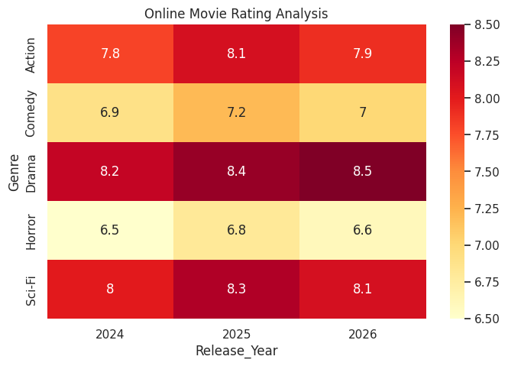

Scenario 9: COVID-19 State-wise Analysis
CODE:
import pandas as pd
import matplotlib.pyplot as plt
import seaborn as sns
sns.set(style="whitegrid")
df = pd.DataFrame({
"State": ["Tamil Nadu", "Karnataka", "Kerala", "Maharashtra", "Delhi"],
"Active_Cases": [1200, 900, 700, 1500, 500],
"Vaccination_Percentage": [88, 85, 90, 84, 92],
"Population": [77000000, 68000000, 35000000, 124000000, 19000000]
})
tile_data = df.set_index("State")[["Active_Cases"]]
plt.figure(figsize=(6,4))
sns.heatmap(tile_data, annot=True, cmap="Reds")
plt.title("COVID-19 State-wise Active Cases")
plt.show()
OUTPUT:
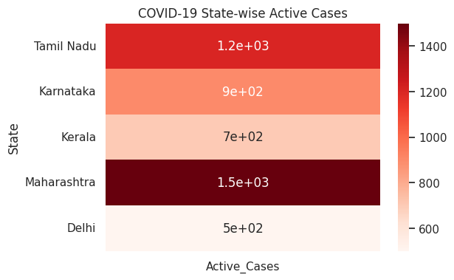
Scenario 10: Iris Flower Classification
CODE:
import matplotlib.pyplot as plt
import seaborn as sns
sns.set(style="whitegrid")
df = sns.load_dataset("iris")
plt.figure(figsize=(9,6))
sns.scatterplot(
data=df,
x="sepal_length",
y="petal_length",
hue="species",
style="species",
size="sepal_width",
sizes=(40, 200)
)
plt.title("Iris Flower Classification")
plt.xlabel("Sepal Length")
plt.ylabel("Petal Length")
plt.show()
OUTPUT:
